/*Assignment based on Constructors and Exception handling in Java*/

Program 1-Constructor

public class Student4

{

int id;

String name;

Student4(int i,String n)

{

id = i;

name = n;

}

void display()

{System.out.println(id+" "+name);}

public static void main(String args[]){

Student4 s1 = new Student4(111,"Karan");

Student4 s2 = new Student4(222,"Aryan");

s1.display();

s2.display();

}

}

Output-

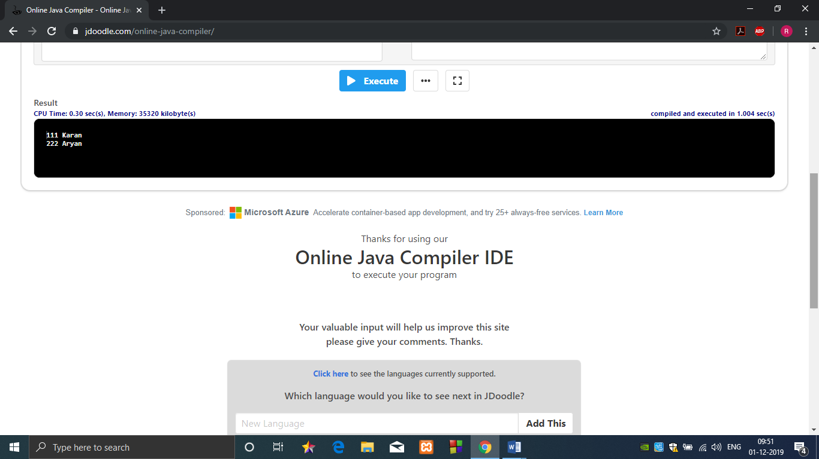

Program 2-Exception Handling

public class ArithmeticException_Demo

{

public static void main(String args[])

{

try {

int a = 30, b = 0;

int c = a/b; // cannot divide by zero

System.out.println ("Result = " + c);

}

catch(ArithmeticException e) {

System.out.println ("Can't divide a number by 0");

}

}

}

Output-

